LABORATORY OBSERVATION / RECORD
Course:Full Stack Web Development
Course Code:23CM4121
Experiment No.:1 ( task-2)
Student Name : Kottana Roshini
Roll No.:A24126552263
1. TITLE
Style the College Information Portal Web Page Using CSS3.
2. AIM
To style the previously developed College Information Portal HTML5 page using CSS3 — applying colors, fonts, borders, gradients, box-shadow, text-shadow, border-radius and hover effects — through an external, linked stylesheet in a black-and-white theme.
3. OBJECTIVE
- To understand CSS syntax and the different types of CSS selectors.
- To apply background colors and linear gradients.
- To style fonts, borders, margins and padding.
- To apply box-shadow and text-shadow effects.
- To create rounded corners using border-radius.
- To create hover effects for navigation links, buttons and content cards.
- To link an external CSS file to an HTML document.
4. THEORY
CSS3 (Cascading Style Sheets, level 3) is used to control the presentation of HTML elements, separating content (HTML) from design (CSS). CSS rules consist of a selector and a declaration block containing property-value pairs.
The CSS box model — margin, border, padding and content — determines the spacing and sizing of every element. Additional CSS3 features used here include linear-gradient() for smooth colour transitions, box-shadow and text-shadow for depth effects, border-radius for rounded corners, and the :hover pseudo-class for interactive feedback when the mouse pointer is over an element.
An external CSS file (style.css) is linked to the HTML document using <link rel="stylesheet" href="style.css"> inside the <head> section. This keeps the stylesheet reusable and separate from the page structure, so the same design can be applied consistently across multiple pages.
5. ALGORITHM / PROCEDURE
- Create a new file named style.css in the same folder as index.html.
- Link style.css to index.html using the <link> tag inside <head>.
- Define base styles for body: font family, text colour and background colour.
- Style the header with a linear-gradient background and text-shadow.
- Style the navigation bar and add a :hover effect on navigation links.
- Style the table with borders, header shading and alternating row colours.
- Style the form with border, border-radius, padding and box-shadow.
- Add a :hover effect on the submit/reset buttons.
- Style the canvas element with a border to visually separate it from the page.
- Style the content cards using a gradient background, border-radius and box-shadow, with a :hover effect that lifts the card and deepens the shadow.
- Style the footer with a solid background colour and centred text.
- Save the file, refresh index.html in the browser and verify every styled section.
6. PROGRAM
File: style.css
/* ==============================================================
Observation Task 2 — CSS3 Styling (Black & White Theme)
============================================================== */
/* ---------- CSS Syntax / Selectors / Base ---------- */
* {
box-sizing: border-box;
}
body {
margin: 0;
padding: 0;
font-family: 'Segoe UI', Arial, sans-serif;
color: #000000;
background-color: #ffffff;
line-height: 1.6;
}
/* ---------- Student Info Bar ---------- */
.student-bar {
background-color: #000000;
color: #ffffff;
text-align: center;
padding: 6px 10px;
font-size: 0.85rem;
letter-spacing: 0.5px;
}
/* ---------- Header ---------- */
header {
background: linear-gradient(135deg, #000000, #4d4d4d);
color: #ffffff;
text-align: center;
padding: 40px 20px;
text-shadow: 2px 2px 4px rgba(255, 255, 255, 0.3);
}
header h1 {
margin: 0 0 10px 0;
font-size: 2.4rem;
letter-spacing: 1px;
}
/* ---------- Navigation Bar ---------- */
nav {
background-color: #1a1a1a;
padding: 12px 0;
box-shadow: 0 4px 8px rgba(0, 0, 0, 0.3);
}
.navlinks {
list-style: none;
display: flex;
justify-content: center;
flex-wrap: wrap;
margin: 0;
padding: 0;
}
.navlinks li {
margin: 0 15px;
}
.navlinks a {
color: #ffffff;
text-decoration: none;
font-weight: bold;
padding: 6px 10px;
border-radius: 4px;
transition: all 0.3s ease;
}
/* Hover effect for navigation links */
.navlinks a:hover {
background-color: #ffffff;
color: #000000;
text-shadow: none;
}
/* ---------- Main / Sections / Articles ---------- */
main {
max-width: 960px;
margin: 0 auto;
padding: 20px;
}
section {
margin-bottom: 40px;
padding-top: 10px;
border-top: 2px solid #000000;
}
article h2 {
border-left: 6px solid #000000;
padding-left: 12px;
font-size: 1.6rem;
}
article h3 {
margin-top: 20px;
text-decoration: underline;
}
/* ---------- Tables ---------- */
table {
width: 100%;
border-collapse: collapse;
margin-top: 15px;
box-shadow: 0 2px 6px rgba(0, 0, 0, 0.2);
}
th, td {
border: 1px solid #000000;
padding: 10px;
text-align: left;
}
th {
background-color: #000000;
color: #ffffff;
}
tbody tr:nth-child(even) {
background-color: #f2f2f2;
}
/* ---------- Images / Figures ---------- */
figure {
display: inline-block;
margin: 10px 20px 10px 0;
text-align: center;
}
figure img {
border: 2px solid #000000;
border-radius: 8px;
box-shadow: 3px 3px 8px rgba(0, 0, 0, 0.3);
}
figcaption {
margin-top: 6px;
font-style: italic;
font-size: 0.9rem;
}
/* ---------- Forms ---------- */
form {
background-color: #f7f7f7;
border: 1px solid #000000;
border-radius: 10px;
padding: 25px;
box-shadow: 4px 4px 10px rgba(0, 0, 0, 0.25);
max-width: 500px;
}
form label {
display: inline-block;
width: 150px;
font-weight: bold;
margin-top: 10px;
}
form input[type="text"],
form input[type="email"],
form input[type="password"],
form input[type="date"],
form input[type="number"],
form select,
form textarea {
border: 1px solid #000000;
border-radius: 4px;
padding: 6px;
margin-top: 10px;
width: 60%;
font-family: inherit;
}
fieldset {
border: 1px solid #000000;
border-radius: 6px;
margin-top: 15px;
}
legend {
font-weight: bold;
padding: 0 8px;
}
form button {
background-color: #000000;
color: #ffffff;
border: none;
border-radius: 6px;
padding: 10px 20px;
margin: 15px 8px 0 0;
cursor: pointer;
font-weight: bold;
transition: all 0.3s ease;
}
/* Hover effect for buttons */
form button:hover {
background-color: #ffffff;
color: #000000;
border: 2px solid #000000;
box-shadow: 0 0 8px rgba(0, 0, 0, 0.5);
}
/* ---------- Canvas ---------- */
canvas {
border: 2px dashed #000000;
border-radius: 6px;
display: block;
margin-top: 10px;
background-color: #ffffff;
}
/* ---------- Content Cards ---------- */
.card-container {
display: flex;
gap: 20px;
flex-wrap: wrap;
margin-top: 15px;
}
.card {
flex: 1 1 250px;
background: linear-gradient(160deg, #ffffff, #d9d9d9);
border: 1px solid #000000;
border-radius: 12px;
padding: 20px;
box-shadow: 4px 4px 12px rgba(0, 0, 0, 0.3);
text-shadow: 1px 1px 1px rgba(0, 0, 0, 0.1);
transition: transform 0.3s ease, box-shadow 0.3s ease;
}
/* Hover effect for cards */
.card:hover {
transform: translateY(-6px);
box-shadow: 6px 10px 18px rgba(0, 0, 0, 0.4);
}
.hover-btn {
background-color: #000000;
color: #ffffff;
border: none;
border-radius: 20px;
padding: 8px 16px;
margin-top: 10px;
cursor: pointer;
transition: all 0.3s ease;
}
.hover-btn:hover {
background-color: #ffffff;
color: #000000;
border: 2px solid #000000;
}
/* ---------- Footer ---------- */
footer {
background-color: #000000;
color: #ffffff;
text-align: center;
padding: 18px;
margin-top: 30px;
}
7. CODE EXPLANATION
Code | Explanation
* { box-sizing: border-box; } | Ensures padding and border are included within an element's declared width/height.
background: linear-gradient(135deg, ...) | Creates a smooth colour transition used for the header background.
text-shadow: 2px 2px 4px rgba(...) | Adds a soft shadow behind text to improve depth and readability.
.navlinks a:hover { ... } | Changes the background/text colour of a nav link only while the mouse hovers over it.
border-collapse: collapse; | Removes double borders between adjacent table cells for a clean grid look.
box-shadow: 4px 4px 10px rgba(...) | Adds a drop-shadow around the form and cards to create a raised, 3D appearance.
border-radius: 10px / 12px; | Rounds the corners of the form and content cards.
.card:hover { transform: translateY(-6px); } | Lifts a content card upward on hover, combined with a deeper shadow for a lift effect.
transition: all 0.3s ease; | Smoothly animates property changes (e.g. colour, shadow) over 0.3 seconds instead of an instant jump.
nth-child(even) | Selector used to shade alternate table rows for readability.
8. TEST CASES AND EXECUTION DATA
Test Case | Action | Expected Result | Actual Result | Status
TC-01 | Open index.html with style.css linked | Page renders fully styled in black & white theme | Page rendered as styled | Pass
TC-02 | Hover over navigation links | Link background turns white, text turns black | Hover effect worked correctly | Pass
TC-03 | Hover over Submit/Reset buttons | Button colours invert with a visible border | Hover effect worked correctly | Pass
TC-04 | Hover over a content card | Card lifts slightly and shadow deepens | Card lift effect worked correctly | Pass
TC-05 | Inspect table rows | Alternating rows are shaded light grey | Alternating shading displayed correctly | Pass
TC-06 | Inspect header section | Gradient background with shadowed heading text is visible | Gradient and text-shadow rendered correctly | Pass
TC-07 | Resize browser window | Cards wrap responsively using flexbox | Cards wrapped correctly on smaller widths | Pass
9. OUTPUT
Output 1: Header Gradient, Text-Shadow and Navigation Hover Styling
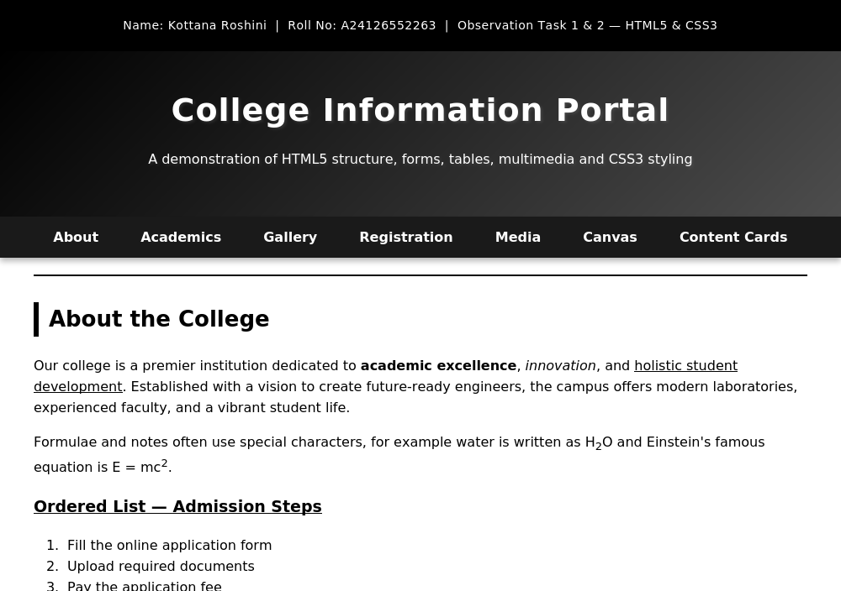
Output 2: Table Shading and Form Box-Shadow / Border-Radius
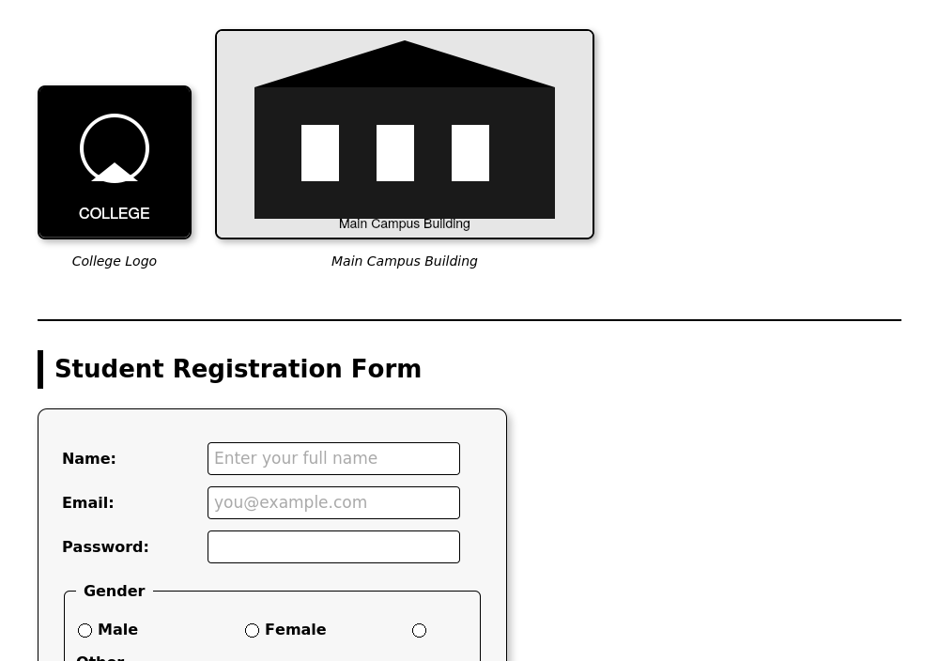
Output 3: Content Cards — Gradient Background, Box-Shadow and Hover Effect
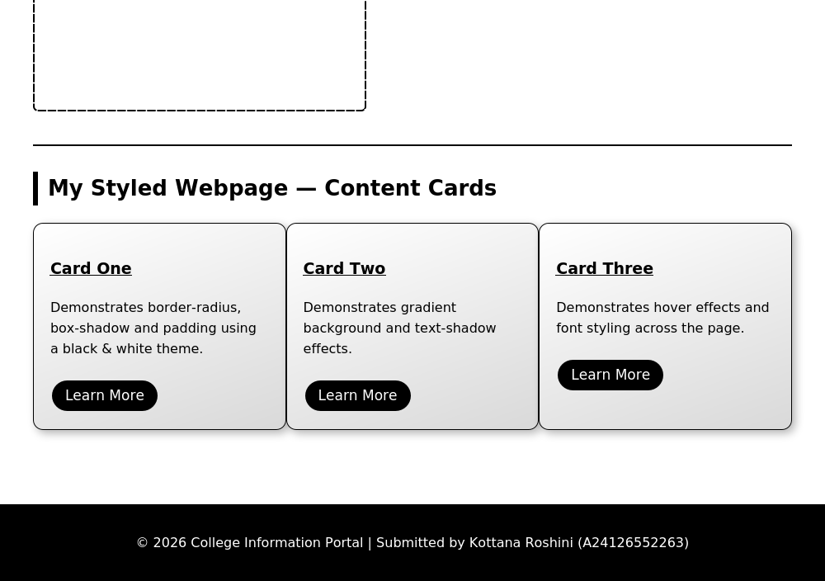
10. RESULT
Thus, the College Information Portal web page was successfully styled using CSS3. Gradients, box-shadow, text-shadow, border-radius, alternating table shading and hover effects on navigation links, buttons and content cards were implemented in style.css and linked to index.html, and the styled output was verified using multiple test cases with the expected result obtained.

